# Written report for the statistical analysis

# Overview of the analysis:

The project is to analyse weather for Hawaii for the month of June and December to understand level of precipitation and temperature.

This analysis is important to check if the proposed venture to open Surf n Shake shop in Hawaii is not drained out due to weather condition.

The earlier investment on Surf shop was drained out due to poor weather condition in Hawaii so the investors will be focussing on weather analysis

report in the business plan. For doing weather analysis, I have used sqlite and sqlAlchemy to retrive weather data for couple of years.

I have used sqlite for sharing my analysis to investor through webage who may not like to run my codes in the particular application.

#Results: Provide a bulleted list with three major points from the two analysis deliverables. Use images as support where needed.

# I have analysed weather condition for the month of June and December which seems to be the month when more tourist will visit Hawaii.

# June and Dec weather statistics are as displayed below

December June

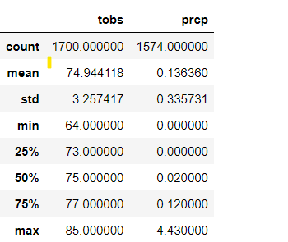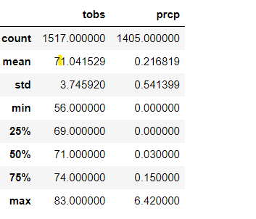

# Looking at the above summary statistics, it appears that weather at Hawaii is very similar in June and December, Max precipitation in Dec is 6.4 vs 4.43 in June and corresponding max tobs is 83 and 85 degree Fahrenheit, the average tobs in Dec is 71 vs 74.9 in June.

# The weather statistics can be compared between these two months by seeing the scattered chart

Dec June

# Looking into the scattered chart, we can see concentration of temperature and precipitation is in the range of 60-70 and 0 to 08 in both months.

#Summary:

# After analysing weather data for June and December, we can conclude that, weather condition is similar in June and December as temperature and precipitation are concentrated within the same range hence there seems to be no surprise with respect to weather condition if we open Surf N Shake shop.

# Since we have done statistical analysis for all stations, we should also do separate analysis for the stations where more data are recorded and also look for information about the station where very less data were recorded with respect to temperature and precipitation. This analysis will help to decide if it is worthwhile to open shops in the location near such station as well as get more clear statistical data about the stations where we are targeting to open initials shops.